CPSC 3310 – Object Oriented Programming

Final Project Report

Eugene Herron III & Daniel Paz

**Planning**

In preparation for the DVD Store project, we prepared two UML’s, one for the use cases and another for the classes.

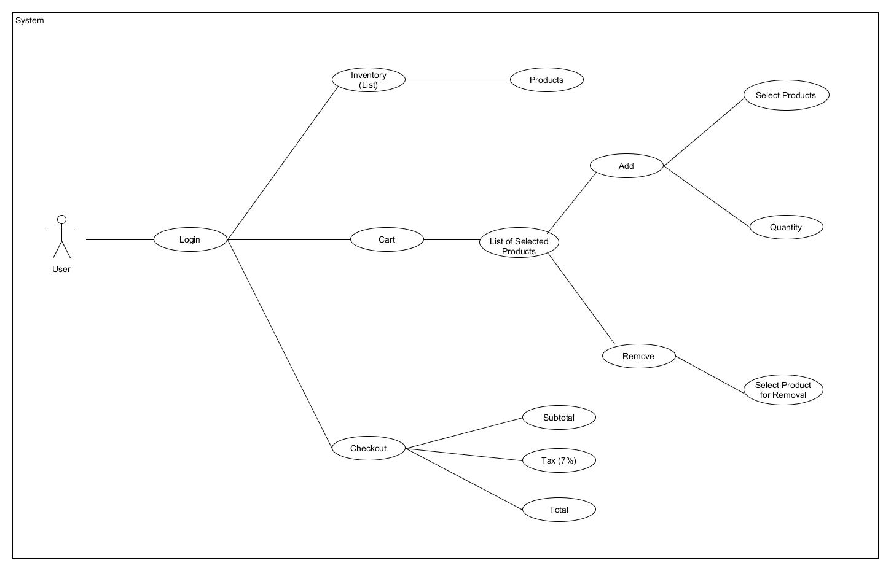

Use case UML

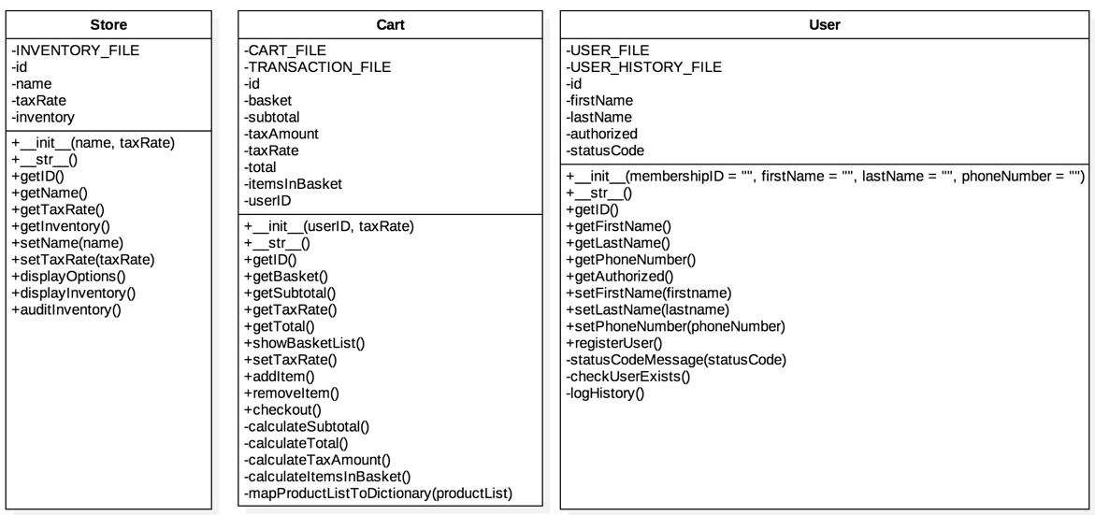

Class UML

**Program overview**

The approach we took for our DVD Store was a literal representation of a real-life video store that required membership to enter.

After the program launches the user is prompted to either Login, Register or Exit (see figure ss-1 and ss-2). The user cannot proceed if something other than these three options are provided as input.

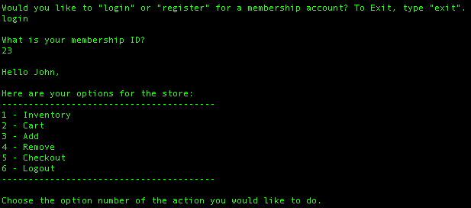

Figure ss-1 – Screenshot of a user trying to login

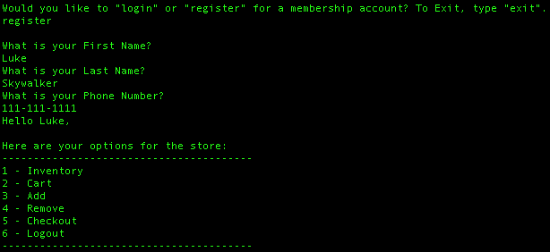

Figure ss-2 – Screenshot of a user trying to register

Once the user has successfully authenticated (implicitly done when registering), a list of browsing options are presented to the user (figure ss-3).

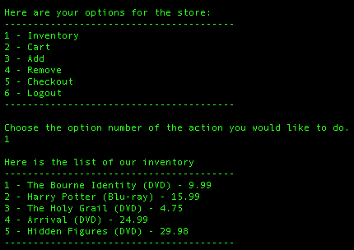

Figure ss-3 – Screenshot of Store options

Inputting **1** (*Inventory)* will render all the products available in a store’s inventory which are read from the products.csv file.



Figure ss-4 – Screenshot of inventory list

Inputting **2** *(Cart)* displays all the contents of the cart.

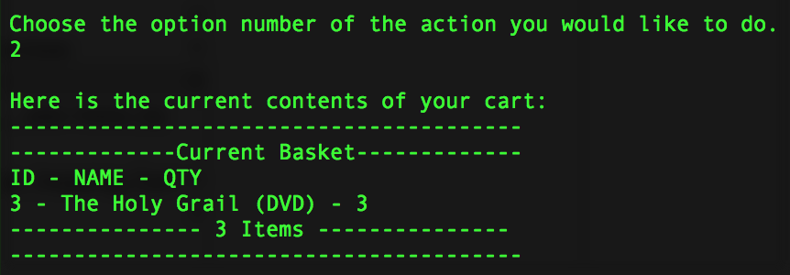

Figure ss-5 – Screenshot of Cart listing

Inputting **3** *(Add Item)* will add the item to the cart, but the user must specify the ID of the product (from the inventory list) and the quantity they wish to add.

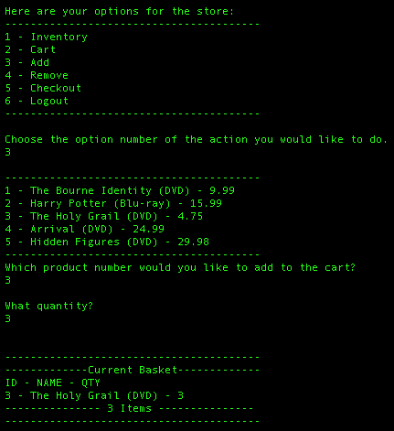  
Figure ss-6 – Screenshot of Adding an inventory item to cart

Inputting **4** *(Remove Item)* will remove a specified quantity for an item from the cart.

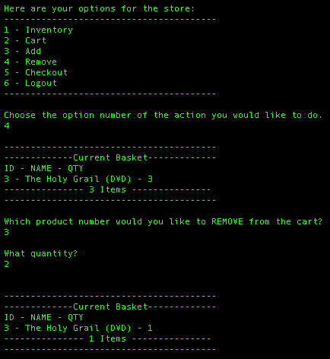  
Figure ss-7 – Screenshot of Removing an inventory item from the cart

Inputting **5** *(Checkout)* runs the user through the checkout process by displaying the subtotal and total. Behind the scenes, the users cart details are added to a cart.csv file and transaction.csv file.

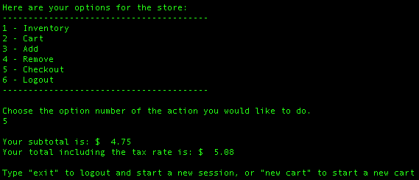  
Figure ss-8 – Screenshot of checkout procedure

Finally, either typing “logout” after checkout or providing an input of **6** *(logout)* from the option’s list will logout the user from their browsing session and prompt the user to login, register or exit again.

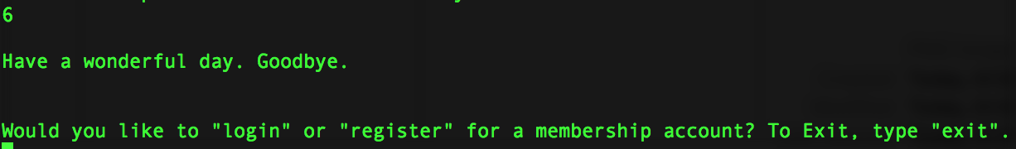  
Figure ss-9 – Screenshot of logging user out

**Project Overview**

Overall the program utilizes a significant number of concepts discussed throughout the OOP class, however we heavily relied on while loops, lists and dictionaries.

The use of while loops made sense to iterate through predefined options an infinite amount of times as long as the user wished to run a certain option. The use of lists and dictionaries came down to the type of sequenced data was at hand. If we needed to store data in memory from a source that was unchanging, ie. inventory, we opted to use lists. Using a list made it easier to rely on the index number automatically assigned when appending an element to a list. However, when we needed to store data based on a unique ID and did not know if said ID would be sequenced in order, we used dictionaries – this was the case for the shopping cart. For example, the basket gave us the flexibility to store an item with ID **5** from the inventory into the dictionary without needing to have 5 others added before it.

Additional concepts applied was the planning of a classes. Specifically, the project gave insight on how to determine whether a complete set of getters and setters were required as well as the type of security to place on those methods. Also, considerations needed to be made when an object needed to interact with properties and methods of another.

**Contribution**

The project was tracked using Github, so a close look at the branches, specifically the [dev branch](https://github.com/soundzofstatic/dvd_store) will provide insight on what each team member contributed. But, to summarize:

* Eugene:
  + Store Class
  + Cart Class:
    - Checkout method
  + Index.py:
    - List/Inventory
    - Checkout
    - Cart
  + Use Case UML
* Dan
  + Cart Class
  + User Class
  + Index.py
    - User Login/Registration
    - Add Item
    - Remove Item
    - Logout
  + Class UML

**Links**

Github *Master* Branch: <https://github.com/soundzofstatic/dvd_store>

Github *Dev* Branch: <https://github.com/soundzofstatic/dvd_store/tree/dev>

Github *danbranch* Branch: <https://github.com/soundzofstatic/dvd_store/tree/danbranch>

Github *genebranch* Branch: <https://github.com/soundzofstatic/dvd_store/tree/genebranch>